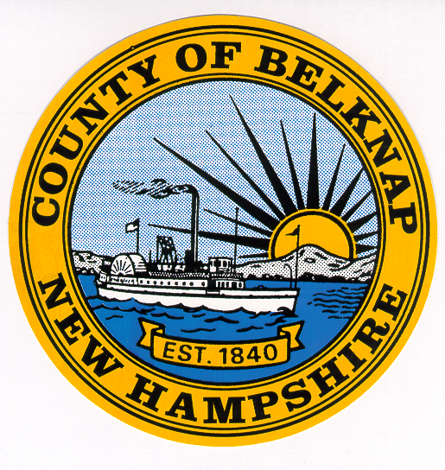 Belknap County

Annual Budget Request from Outside Agencies

Part A – Agency Information

Agency Name: | Date:
Address: | Email:
Telephone: | Fax:
Executive Director: | Agency Fiscal Year:

Section 1 – Funding Request Summary:

Total Amount of Request: $
Funds for:

General Operations and Overhead Amount $

Existing Program, Identify: Amount $

New Program, Identify: Amount $

Section 2 – Revenue Summary: (Detail of all sources – use extra space if necessary)

Revenue Sources | Prior | Current | Requested
Federal: (list)
State Funds: (list)
Belknap County:
Client Fees-Public:
Client Fees-Private:
USDA-CACFP:
Municipalities: (total)
Other:
Other:
Other:
Other:
**TOTAL:

**Total should match total revenues reported on financial statement and IRS Form 990.

NOTE: Please define initials, acronyms, etc.:

Section 3 – Agency Municipal Government Revenue:
Please list revenues received from Municipal Governments in Belknap County:
Municipality | Date of Last Application | Prior | Current | Projected/Requested
Alton
Barnstead
Belmont
Center Harbor
Gilford
Gilmanton
Holderness
Laconia
Meredith
Moultonboro
New Hampton
Sanbornton
Tilton
TOTAL:

Section 4 – Agency Budget Overview:
 | Prior Year | Current Year | Projected Year
Total Revenue
Total Expenses
Surplus/Deficit

Section 5 – Agency Budget Breakdown for all Programs:
Revenues by Program
Programs | Prior Budget Allocation | Current Budget Allocation | Proposed Budget Request
TOTAL

Expenses by Program
Programs | Prior Budget  Expense | Current Budget Expense | Proposed Budget Expense
TOTAL

Section 6 – Audited Financial Report: Attach one copy of your latest audited financial report.
Section 7 – IRS Form 990, Return of Organization Exempt From Income Tax: Attach one copy of your latest Form 990 as submitted to the Department of the Treasury, IRS.
Part B – Program Specific Information
Important Note: Please complete sections 8 – 14 for each program requesting County Funding.

Section 8 – Program Funding Request:

Program Name:

Amount of Request for this Program: $
Existing Program New Program

Will funds be matched?

By: Federal State Municipal Private No.

If yes, how?

If no, why not?

Section 9 – Program Expense Summary:
Expense Item | Prior | Current | Proposed
Personnel Services
Contract Services
Travel
Space/Rent
Consumable Supplies
Equipment
Telephone
Membership Dues
Printing
Food
Insurance
All Other
TOTAL:

Section 10 – Program Revenue Summary:
Revenue Sources | Prior | Current | Proposed
Federal (list)
State (list)
United Way
Belknap County
Client Fees-Public
Client Fees-Private
USDA-CACFP
Municipalities
Other
Other
TOTAL:
Section 11 – Program Personnel Summary:
# FTE’s | Position / Title | # of hours * | Prior Salary | Current Salary | Proposed Salary
TOTAL

* Number of hours worked per year. Fulltime for a full year is 2,080 hours.

Section 12 – Fringe Benefits:
Type of Benefit | Cost | Explanation
Workers Compensation
FICA
State Unemployment
Health/Dental Insurance
Other (vehicle, housing, life, etc.)
TOTAL

Section 13 – Program General Information, Update, Service Goals, and Objectives.

Please attach a document that separately answers the following questions (reference each question by number).
- 1. Please LIST the program’s mission, goals, and objectives.
- 2. Describe the program and/or general operations for which you request this money.
- 3. Break-down the monies as to which area they will be used is $ amount.
- 4. Please describe how this program evaluates and measures effectiveness.
- 5. Describe how and how many (in hours) volunteers this program uses.
- 6. Describe your program’s efforts re: cooperation and collaboration with other agencies.
- 7. Describe your program’s target population.
- 8. Please LIST any major changes in service since your last review. Were changes due to funding cuts, reduction in program, increased efficiencies?
- 9. Please LIST the number of new positions next year.
- 10. Please LIST the number of positions eliminated next year.
- 11. LIST and describe any major purchases the program plans for next year.
- 12. LIST past year fund raising events and detail amounts received (gross/net), are these events to be held again this year.
- 13. Does this program use a sliding fee scale (describe)?
- 14. Please LIST the unit of service in terms of dollar cost per hour per individual served, and describe a unit of service for this program. Is the unit of service a full hour?
- 15. How many units can the program provide?
- 16. How many perspective recipients are on your waiting list?
- 17. How long will it be (in days) before your program can serve the first person on the waiting list?

Section 14 – Program Beneficiary Statistics
 | Prior | Current | Projected
1. Total count of clients
2. Age Groups
a. 0 to 5 years
b. 6 to 17 years
c. 18 to 61 years
d. 62 to older
e. not known
3. By Town of Residency
Alton
Barnstead
Belmont
Center Harbor
Gilford
Gilmanton
Laconia
Meredith
New Hampton
Sanbornton
Tilton

